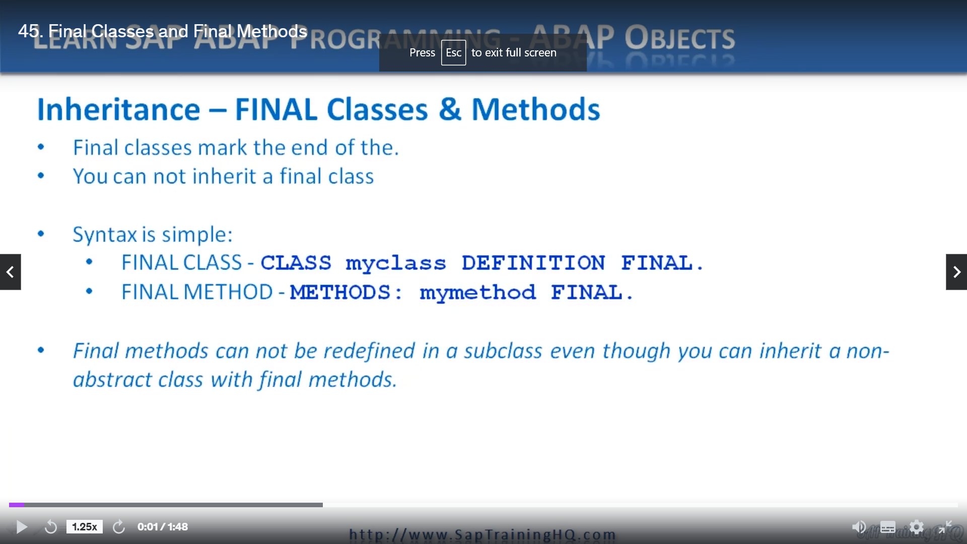

This lesson is all about Mark in your classes and methods as final.

Now, there are times when you do not want your classes and methods to be inherited.

Abbott allows us to specify this by using the final audition for our classes and methods, you can see

on the screen here the simple syntax when we're defining our class after the definition, we are the

additions final.

Same thing for methods.

We have methods, the method name and then we have the addition final.

Now, there are some reasons why you may want to do this, and if you think, well, you're developing

your class, you're developing your methods, but maybe they're not fully complete and you know that

in the future you were going to be changing the way that maybe the interfaces are defined or the actual

functionality is defined within the methods themselves.

If someone was to inherit the functionality within this class that, you know, you're going to change

and they rely on your class, well, when you make those changes, you run the risk of causing their

code to become invalid.

So to safeguard against this, you can add the word final at the end of your classic method definitions.

Now, one thing to know is that if you define a final method inside a non abstract class, the class

can still be inherited in a subclass, but you cannot redefine the method.

So just bear that in mind.

This one's a really short lesson.

We don't really need to implement the code for this because all you need to do is add the word final.

So let's move on to the next lesson.